April 28, 2020

Dear 12th-grade students and families,

I hope this letter finds you and your family well during this unprecedented time.

On April 9, we shared the disappointing news that our school buildings would remain closed for the rest of the school year and that the school-sponsored social events you’ve been looking forward to all year, such as proms and graduation, would be cancelled due to the COVID-19 pandemic. While these choices were made with the safety and well-being of our students in mind, that doesn’t make them any less painful -- for you and for all of us. Even though these events cannot move forward in a traditional way, we remain fully committed to safely celebrating the Class of 2020 starting in late May. You deserve that and so much more. I’m writing today to share some of our plans with you.

Class of 2020 Celebrations
A planning team has been working together with members of my Student Advisory Council to create some exciting and memorable experiences for the Class of 2020, including:
- a District-wide virtual graduation with special performances, a surprise (for now) celebrity guest speaker and a special, shareable invitation to help you engage family and friends in your graduation experience,
- a virtual graduation after-party hosted by a popular DJ,
- a citywide advertising campaign with customized ads for each District high school,
- a student-led social media campaign where you can rep your school, and
- an opportunity for every Philadelphian across the city to engage in a simultaneous activity to honor the Class of 2020.

In addition to these plans, Individual high schools may choose to host their own virtual graduation or party for their students in June. School staff will provide more information if they are pursuing this option. With safety as our top priority, no in-person events for seniors will be planned by the District or your school until further notice.

Beyond June 2020
We realize that no virtual program can take the place of walking across the graduation stage in your cap and gown with classmates and throwing your cap in the air to culminate your years of hard work. We will work with our high schools to try and provide a more traditional experience for you once the shelter-in-place and social distancing orders are officially lifted. Please know that it will likely be some time before this occurs.

An Update on Dues/Fees Paid
The District continues to work with high schools to determine the process for refunds. Refunds will vary by school based on each school’s dues package and planning status. For example, in cases where goods such as yearbooks and senior t-shirts have been ordered, you can still expect to receive those goods when and how it is safe to provide them. However, in cases where down payments have been made for venues, we will need time to determine how and if schools will be reimbursed by the venues. We ask for your continued patience as we work through the complexities of this situation in the coming weeks. Also, if you have not yet paid dues, individual schools may still allow you to pay them so that you can receive some of the items included in their dues packages. More information will be provided by your school in the coming weeks.

As we close out this school year, you can also expect more information about opportunities to safely re-enter our schools to retrieve any personal items you may have left in your lockers and drop off any devices, textbooks and sports uniforms.

No matter the circumstance, nothing and no one can take away your years of hard work, grit and perseverance to become a proud School District of Philadelphia Class of 2020 graduate. CONGRATULATIONS! I look forward to safely celebrating with you in the coming weeks and updating you as our plans progress.

In the meantime, please take care and stay safe.

Sincerely,
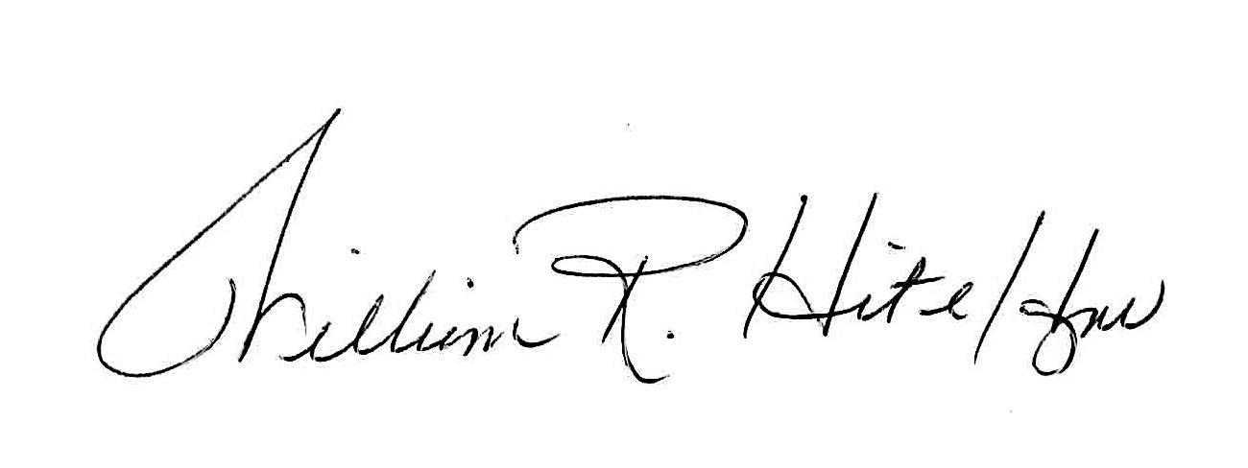
William R. Hite Jr., Ed.D.
Superintendent
The School District of Philadelphia

